
API Application Manual

Topic: | API Application Manual For Vending

Summary | API Application Manual  By reading this document, you can quickly use the API, generate Vending Token，Clear Credit Token and so on.  Hunan Stron Smart Co., Ltd

Catalogue
1 FOREWORD 3
1.1 Prepare 3
1.2 Web Site：Test platform 3
2 Vending API 3
2.1 Send a Clear Credit request to the server 3
2.2 Send a directly Clear Credit request to the server 4
2.3 Send a Clear Tamper request to the server 5
2.4 Send a directly Clear Tamper request to the server 7
2.5 Send a Query Customer Information record request to the server 8
2.6 Send a Query Meter ID Information record request to the server 9
2.7 Send a Query Meter credit record request to the server 9
2.8 Send a Vending request to the server 11
2.9 Send a Vending directly request to the server 13

FOREWORD

Prepare
- Before calling the api, you can input basic data, such as meter ID number, price, customer information, and account opening information, into the system through our Vending management system, so that the API can be executed correctly.
- The account of the Vending management system can be obtained by asking our sales staff.

Web Site：Test platform
Follow below several steps to get token easily by using the API，More detailed API description ，Please refer to the website
http://www.server-newv.stronpower.com/swagger

Vending API

Send a Clear Credit request to the server
Request URL as follows:
http://www.server-newv.stronpower.com/api/ClearCredit
If we want Clear Credit. And the Post Body as follows：
{
"CompanyName": "your company name",
"UserName": "your user name",
"PassWord": "your password",
"CustomerID": "your customer’s id , This number is your own definition",
"METER_ID": " your customer’s Meter id"
}

If I want to Clear Credit of meter 58100000007，and Customer Id is 0001. The vending/API account info: Company Name: stron; User Name: 0000; Pass Word: stron888.
Post Body as follows：
{
"CompanyName": "stron",
"UserName": "0000",
"PassWord": "stron888",
"CustomerId": "0001",
"METER_ID": "58100000007"
}
Operation instance：
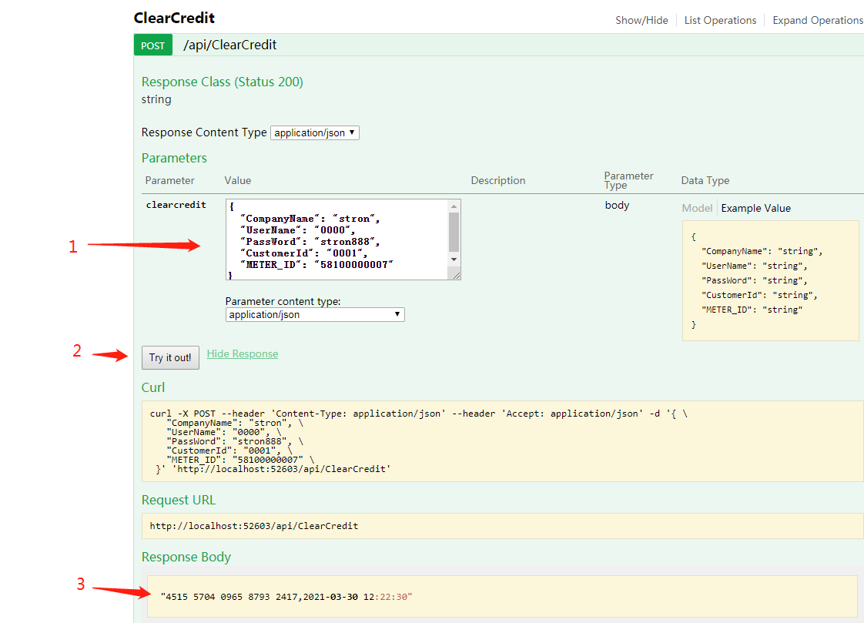
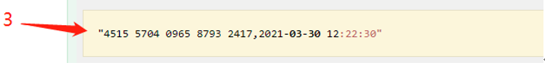

Send a directly Clear Credit request to the server
Request URL as follows:
http://www.server-newv.stronpower.com/api/ClearCreditDirectly
If you want generate the Clear Credit Token, and don’t want to register Price, District, Sales Satations and Customer information into Server. So you can use this kind of API ClearCreditDirectly.

If we want get Clear Credit Token directly. And the Post Body as follows：
{
"CompanyName": "your company name",
"UserName": "your user name",
"PassWord": "your password",
"CustomerID": "your customer’s id , This number is your own definition",
"Meter_ID": "58000000008"
}

Operation instance：
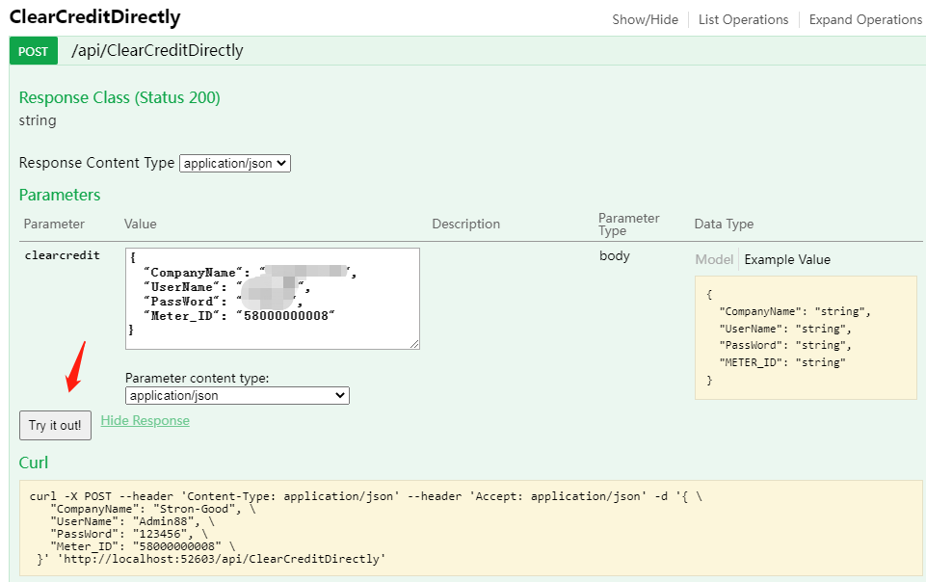
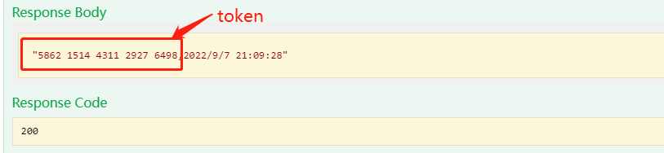

Send a Clear Tamper request to the server
Request URL as follows:
http://www.server-newv.stronpower.com/api/ClearTamper

If we want Clear Tamper. And the Post Body as follows：
{
"CompanyName": "your company name",
"UserName": "your user name",
"PassWord": "your password",
"CustomerID": "your customer’s id , This number is your own definition",
"METER_ID": " your customer’s Meter id"
}

If I want to Clear Tamper of meter 58100000007, and Customer Id is 0001. The vending/API account info: Company Name: stron; User Name: 0000; Pass Word: stron888.
Post Body as follows：
{
"CompanyName": "stron",
"UserName": "0000",
"PassWord": "stron888",
"CustomerId": "0001",
"METER_ID": "58100000007"
}
Operation instance：
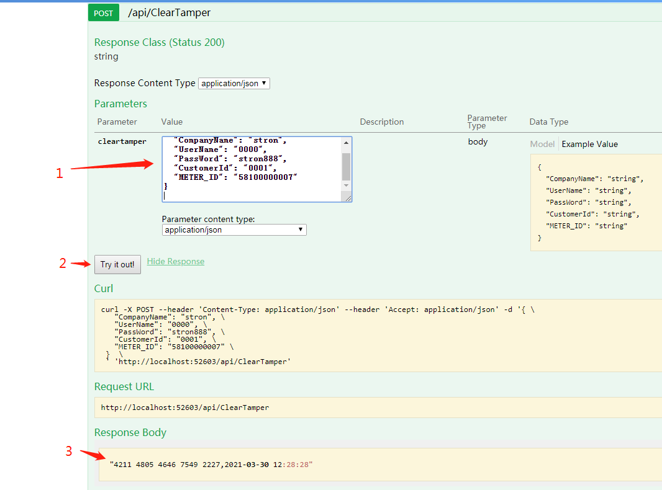
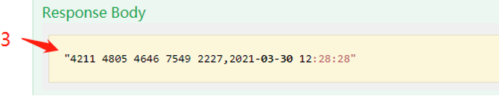

Send a directly Clear Tamper request to the server
Request URL as follows:
http://www.server-newv.stronpower.com/api/ClearTamperDirectly
If you want generate the Clear Tamper Token, and don’t want to register Price, District, Sales Satations and Customer information into Server. So you can use this kind of API ClearTamperDirectly.

If we want get Clear Tamper Token directly. And the Post Body as follows：
{
"CompanyName": "Your company name",
"UserName": "Your name",
"PassWord": "Your password",
"Meter_ID": "58000000008"
}

Operation instance：
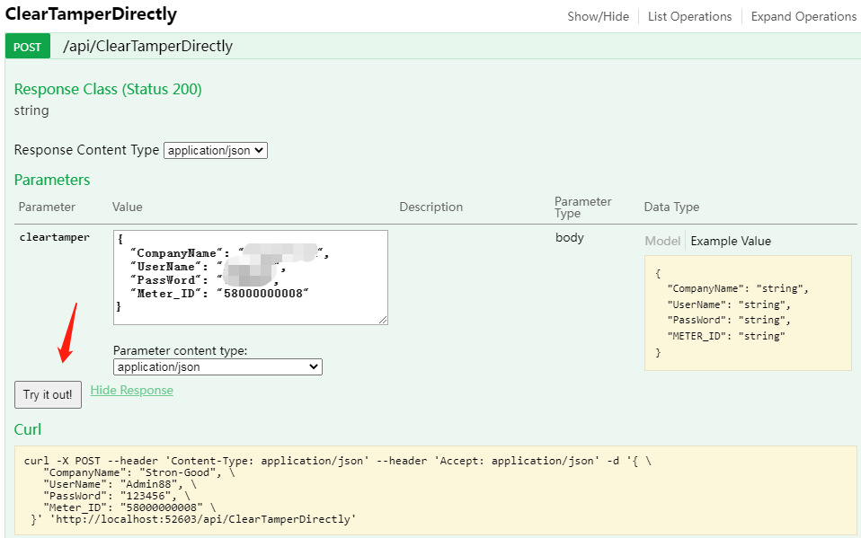
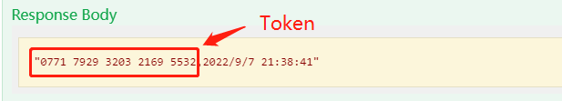

Send a Query Customer Information record request to the server
Request URL as follows:
http://www.server-newv.stronpower.com/api/QueryCustomerInfo

If I want to query credit record of Customer ID: CTS-00001
Post Body as follows：
{
"CompanyName": "Your company name",
"UserName": "Your name",
"PassWord": "Your password",
"CustomerId": "CTS-00001"
}
Operation instance：
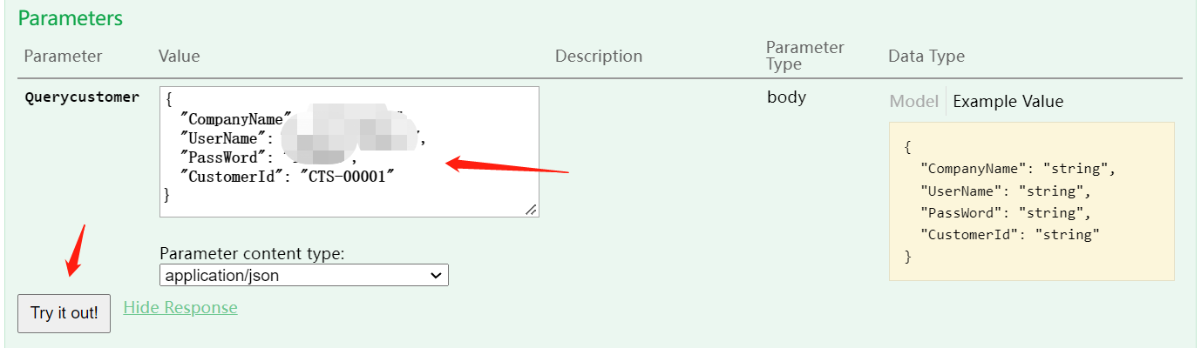
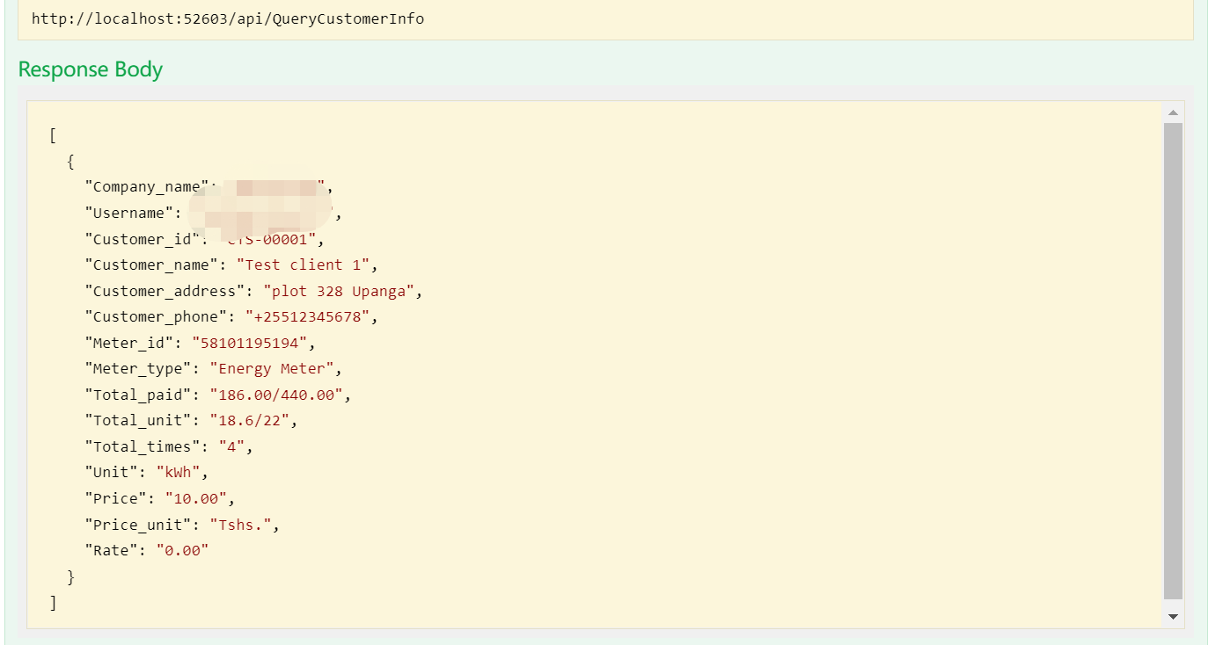

Send a Query Meter ID Information record request to the server
Request URL as follows:
http://www.server-newv.stronpower.com/api/QueryMeterInfo

If I want to query credit record of Meter ID: 58101195178
Post Body as follows：
{
"CompanyName": "Your company name",
"UserName": "Your name",
"PassWord": "Your password",
" MeterId": "58101195178"
}
Operation instance：
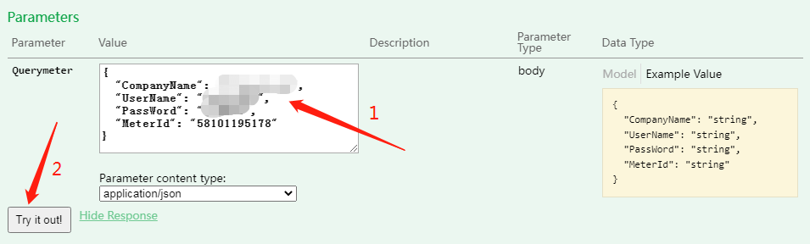
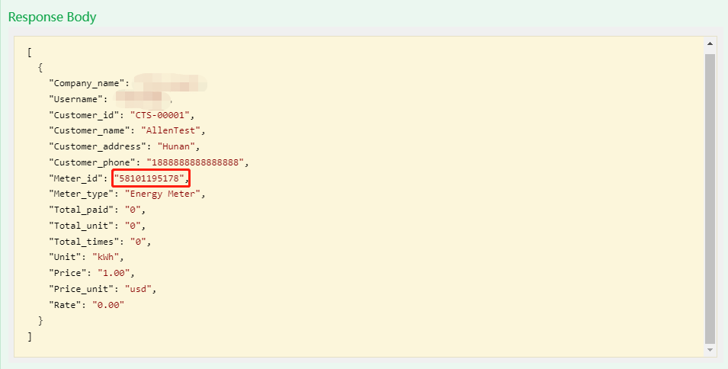

Send a Query Meter credit record request to the server
Request URL as follows:
http://www.server-newv.stronpower.com/api/QueryMeterCredit

If I want to query credit record of Meter ID Number: 58000000024
Post Body as follows：
{
"CompanyName": "Your company name",
"UserName": "Your name",
"PassWord": "Your password",
"MeterId": "58000000024"
}
Operation instance：
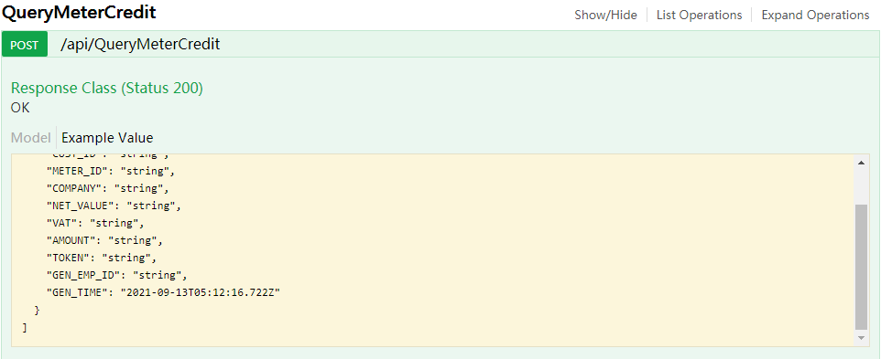
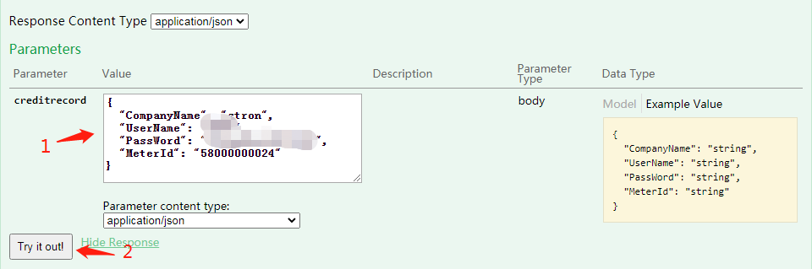
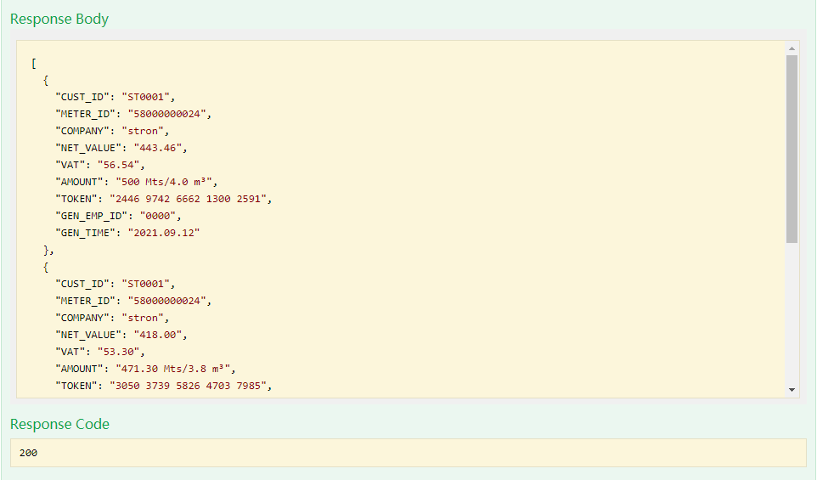

Send a Vending request to the server
Request URL as follows:
http://www.server-newv.stronpower.com/api/VendingMeter

Parameter | Value | Explanation
is_vend_by_unit | true | Vending by unit
 | false | Vending by money

the post Body as follows：
{
"CompanyName": " your company name ",
"UserName": " your user name ",
"PassWord": " your password ",
"MeterID": "string",
"is_vend_by_unit": "true: vending unit . false: vending money ",
"Amount": 0
}

For example , If I want to top up meter ID: 58100000007, the recharge by unit, and the amount is 1700. the post Body as follows：
{
"CompanyName": " your company name ",
"UserName": " your user name ",
"PassWord": " your password ",
"MeterID": "58100000007",
"is_vend_by_unit": "true ",
"Amount": “1700”
}
Notes： if you want vending by unit, the value of “is_vend_by_unit” is true.

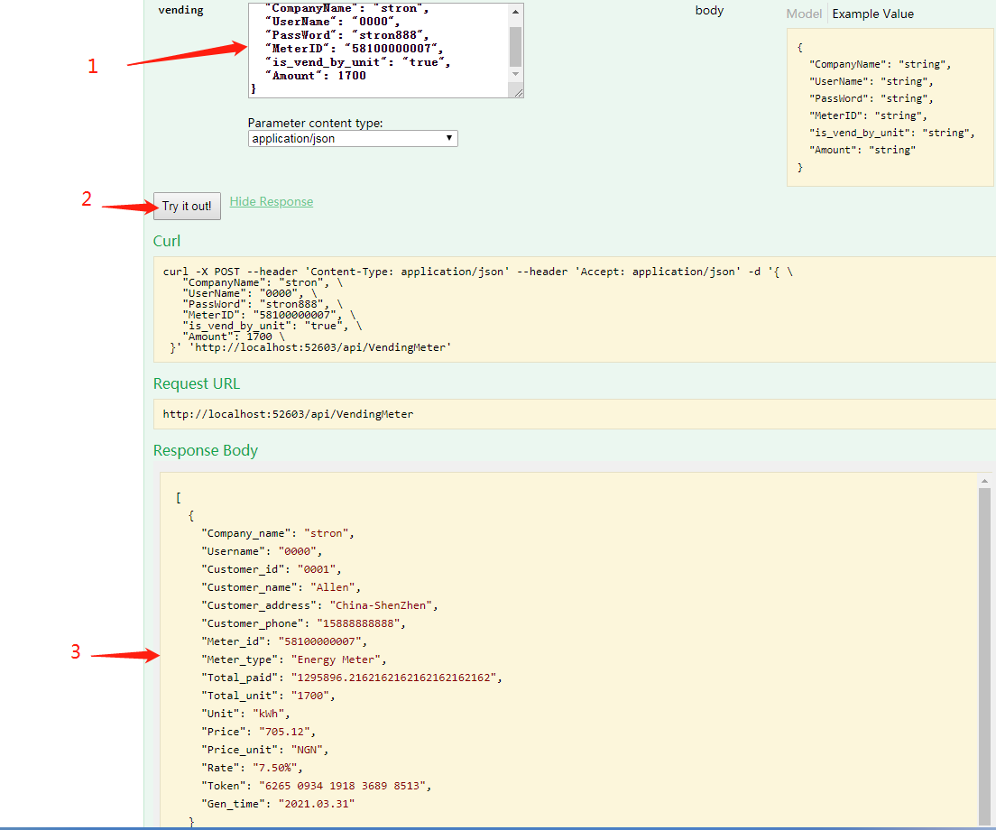

Send a Vending directly request to the server
Request URL as follows:
http://www.server-api.stronpower.com/api/VendingMeterDirectly
If you want generate the Token, and don’t want to register Price, District, Sales Stations and Customer information into Server. So you can use this kind of API VendingMeterDirectly.

If we want generate the Token for Meter 58000000024, Meter type is Energy Meter,and recharge 30kWh.
Post Body as follows：
{
"CompanyName": " your company name ",
"UserName": " your user name ",
"PassWord": " your password ",
"MeterId": "58000000024",
"Amount": "30"
}
Operation instance：
